**The everyday miracle of writing**

**文字虽日常却是奇迹**

(英文部分选自经济学人202200702期文化版块)

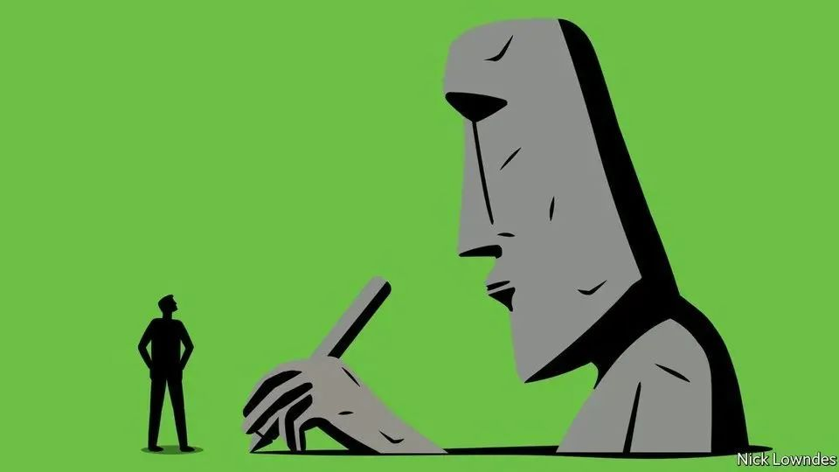

**The everyday miracle of writing**

**文字虽日常却是奇迹**

Give thanks to the people who **resolved to** make pictures **stand for** sounds

向那些致力于用图画表示声音的人致谢

If you are reading this column, a combination of 26 squiggles on a page or screen is putting the sounds and meaning of this sentence into your head almost **without effort** **on your part**, though **you have almost certainly never met the writer**. If you are listening to this on The Economist’s audio edition, a reader **who has also never met the author** has **turned** a copy of those squiggles **into** intelligible sound waves for you.

当你阅读本栏目时，尽管与作者**素昧平生**，但书页或屏幕上由26种涂鸦字母组合而成的单词能让你基本上**毫不费力地**了解句子的读音和含义。如果你正在聆听《经济学人》的音频，那么就又有一位和作者**素不相识**的朗读者把这些字母组合变成有意义的声波，传达给你。

**Writing is such an everyday miracle that it is easy to take for granted.** People who can read cannot stop themselves, as studies have shown in which subjects are told to ignore a word flashing on the screen while attending to another task, but are unable to do so. Reading is the prime goal of education everywhere. **Writing seems so fundamental that** it is hard to believe just how recent, and contingent, it really is.

**文字随处可见，使得我们对这项奇迹习以为常。**研究表明，能认字的人没有办法刻意地不去认字。在这项研究当中，研究人员要求受试者在完成其他任务的同时不去理会屏幕上闪烁的单词，结果却没有人能做到这一点。在全世界范围内，教育的首要目标都是学会阅读。**文字的地位重要到**人们很难相信它的历史其实很短，而且它的诞生也很偶然。

**Estimates differ widely on** when language was developed, from 50,000 years ago to as many as 1.9m years. On even the most recent hypothesis, **(**humans spent 45,000 years talking**) before (**it occurred to a few to make their words into durable visual signs**)**. Writing was then independently invented just four (proven) times, in Mesopotamia, Egypt, China and Mesoamerica. Most people lived without it for a few more millennia. **Only in the 1940s did humankind pass a literacy rate of 50%.**

就语言形成的时间这一问题，**观点众说纷纭**，从 5 万年前到 190 万年前不等。即使是根据最新的假说，人类也是在说话交流了 45,000 年之后，**才**有少数人想到将话语用持久的视觉符号表示。目前已经证实，历史上有四个地方各自独立地发展出了文字系统，分别是美索不达米亚、埃及、中国和中美洲。在后来的几千年间，大多数人继续过着没有文字的生活。**直到 20世纪40 年代，人类的识字率才刚过 50%。**

“The Greatest Invention”, a new book by Silvia Ferrara of the University of Bologna, restores **a sense of wonder** at **the imaginative leaps** required to invent writing. Part of her story (translated by Todd Portnowitz) **is familiar**: the procession from drawings (a picture of a bull is just that, a bit of art) to **visual icons** (just a couple of lines to indicate, say, “house”), to symbols. The leap to symbols is crucial: these are distinct from the original referent, allowing them to **stand for** abstract things, including the many verbs that are hard to picture. Think of the floppy-disk icon meaning “save”, even when no floppy disk is involved.

意大利博洛尼亚大学的西尔维娅·费拉拉（Silvia Ferrara）在她的新书《最伟大的发明》当中再次对发明文字背后的创造性突破表达了赞叹之情。书中部分内容（英译本译者为托德·波特诺维茨）已**为大众熟知**，即文字由图画（例如一幅公牛的图画代表一只公牛，只不过表现得更有艺术性）到图例（举例来说，几根线条便可指代“房屋”）再到符号的演化过程。跨越到符号这一步相当关键，因为象征符号有别于最初的指示物，可以指代抽象的事物，包括很难用图画表示的动词。想想计算机上面的软盘图标，即便不涉及软盘，这一图标也表示“存储”之意。

**Ancient cultures could have stopped at the symbolic phase**, using stylised, stripped-down images to stand for important things and ideas, without intending to represent full sentences. Several, including the Indus Valley civilisation split between today’s India and Pakistan, may have done just that; its script, if indeed it is one, remains undeciphered. But at some point—the Sumerians of the third millenniumbc are usually awarded first prize, though Ms Ferrara makes a case for Egypt—people **stumbled on** the “rebus principle”. This is familiar from modern children’s games in which a bee stands for the verb “be”. In languages like Sumerian that have a small set of simple syllables, a few hundred symbols can represent anything you can say.

**古代文明本可以就此停留在象征符号阶段**，仅采用程式化的简约图像来代表重要的事物和思想，而无需尝试表达完整的句子。有好些古代文明可能的确止步于此，其中之一便是位于当今印度与巴基斯坦的印度河谷文明。该文明留下的印记如果能算是文字的话，至今尚未破译。但在历史上的某个时期，人类偶然创造了“画谜原则”（rebus principle）。尽管费拉拉在书中为埃及人据理力争，但通常认为，生活在公元前3000年的苏美尔人是最早发明这一原则的人群。画谜原则与现代儿童游戏类似：举例来说，这种原则利用发音相同的蜜蜂（bee）图像来代表动词“be”。在苏美尔语这类音节简单且数量有限的语言中，几百个象征符号就足以表达一切想说的内容了。

It may be that all those who invented writing independently relied on the rebus (though Mayan shows scant clear evidence of it). Some moved past it to alphabetic writing, with characters representing sounds, not syllables. But the rebus remains **the core of** the story, **bootstrapping societies from complete ignorance of the very idea of writing to lives that cannot be imagined without it.**

也许，所有独立发明文字的文明都采用了画谜原则（尽管玛雅文明缺乏这方面的清晰证据）。部分文明在此基础上发展出字母书写体系，每个字母代表一个发音，而非音节。但画谜原则仍是人类文字演化史的核心，**助力人类社会从完全不考虑文字发展到如今文字不可或缺的时代**。

Ms Ferrara **dissents from** the narrative in which **civilisation and writing advanced in lockstep**, to serve increasingly bureaucratic states. She thinks the script of Easter Island is another candidate for independent invention, despite the absence of a state. And some states, like the Inca empire, did without writing (though the Incas developed an extraordinary system of knots calledquipu, still only partly understood). **Her book is a joyful tale of writing as a means of self-expression, showing off and play.**

有观点认为，**文明和文字的发展相辅相依**，为日益官僚化的国家机器服务，而费拉拉女士不认同这种观点。她认为，复活节岛的文字系统就是在没有国家的情况下独立发展起来的。而另一些地方虽然建立了国家（比如印加帝国），却没有文字；不过，印加人发展出一套叫做quipu的结绳记事系统，这个系统令人称奇，但目前只有部分被破译。**费拉拉女士的作品以生动有趣的笔触介绍了文字这一表达自我、展现自我以及用来娱乐的工具。**

She describes experiments in which participants played a Pictionary-like game that got them to draw things including “Brad Pitt”. Though **barred from** talking, they could share and revise their solutions. Initially they produced bad pictures of Mr Pitt and his famous then-wife Angelina Jolie. But a few souls **stumbled on** the rebus principle, sketching either a pit in the ground or a stick-man with an arrow pointing to his armpit. Before long, even these were **stripped down**, until a circle (for the head), an angle (a raised arm) and a line (no longer even an arrow) were all that was needed to depict one of the world’s most handsome men. Anyone can invent writing.

费拉拉女士在书中描写了一些实验，实验的参与者玩一种类似于猜猜画画的游戏，画出包括“布拉德·皮特”在内的人或物。参与者可以分享和修改各自的方案，但交谈是严令禁止的。开始的时候，大家将皮特先生和他当时的太太，大名鼎鼎的安吉丽娜·朱莉画得很糟。但是，有几个人在无意中开始使用画谜原则，在地上画一个坑，或者画一个火柴人，再画一只箭指向小人的腋窝。很快甚至这些内容都被省略了，最后只剩下一个圆圈（表示头）、一个角（提起的手臂）和一条线（甚至连箭头都不是了），这些就是这群人描述这位世界上最帅的男人之一所需要的所有元素。任何人都可以发明文字。

But no one did, for aeons of humankind’s linguistic existence. **Everyone who loves to read and write today owes a debt of gratitude to** **those who, whether out of play or necessity, finally had the idea**, obvious only in retrospect, of making pictures stand for sounds.

但是，从人类语言诞生之日起，经历了漫长的时间，也没有人发明文字。只有在回顾历史的过程中，我们才清晰地认识到，**今天每一位喜爱阅读和写作的人都应该对那些灵光一现、想到用图画来代表声音的前人心存感激**，无论这种想法是出于娱乐还是实际需要的目的。